

Metreos Convergence Environment

Application Server Call Processing Overview

January 16, 2004
– DRAFT –

Copyright © 2003-2004 Metreos Corporation
All Rights Reserved

Proprietary and Confidential
For Release under NDA Only

Application Server Technical Overview

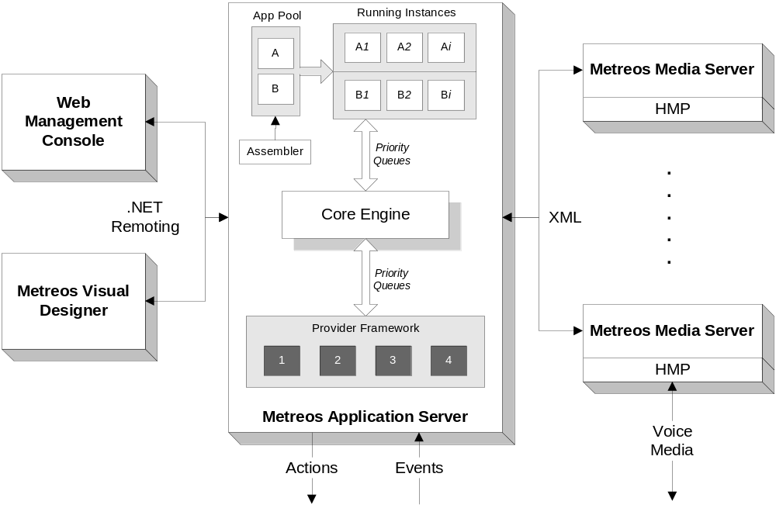

As illustrated in the diagram, the Application Server is composed of three main parts in addition to the supporting functions of the management console, Visual Designer (Max), and the Metreos Media Server. These three parts are: The Application Runtime Environment (ARE), the core, and the protocol providers. It is the protocol providers and their interface to the rest of the Application Server which is the focus of this document. The Application Server exposes a well-defined API which protocol providers use to communicate with applications. This API is centered around the idea that all protocol transactions take place by way of a series of actions and events.

Events are provider-initiated activities which can happen at any time. Usually they are the result of a remote party making a request for a resource by way of a particular protocol. When a provider receives such a request, it formats it into a formal event message and passes it into the Application Server. From there, the Application Server determines if any applications are installed which declare this event as a triggering criteria. If an application is found to handle the event, that application is started and is expected to respond with appropriate actions. If an application is not found, a “No handler” message is sent back to the protocol provider and it is then expected to cancel and terminate the open connection by whatever means is appropriate for that protocol and stack.

In response to an event, and application may issue any number of actions. In the application server, actions can take three forms: provider, native, and application control. Provider actions are those which are exposed by a provider upon its installation. Native actions are custom .NET code segments which are executed within the Application Runtime Environment. Many native actions are included with the Application Server, but it is easy to create more by simply creating a class which inherits from Metreos.ApplicationFramework.NativeActionBase. Finally, application control actions are predefined directives which are built into the Application Runtime Environment. These actions instruct the ARE to do something special in regard to application execution.

Provider actions may be further subclassed into two types: synchronous and asynchronous. Synchronous actions should execute in a relatively short period of time. The ARE will wait for a final response from any synchronous provider action before executing the next action in the application. Asynchronous actions can take any length of time to execute. A provisional response is sent once the activity commences and then a final response is sent once the action has completely finished. The ARE will continue executing actions once it has received the provisional response. The application has functions which are specifically declared to handle the final response from the action. Those functions are able to correlate the final response to the original action by way of the userData field. The value of this field is not used by any provider, but it is present in every asynchronous action and is always hairpinned back to the application in the final response.

One example of this is the Metreos.Provders.MediaServer.PlayAnnouncement action. This action is asynchronous and the media server provider will send a provisional response once it determines that everything is in the proper state to begin playing an announcement to the specified connection (i.e. the file and connection both exist). Once the media server has finished playing the announcement, the media server provider will send a final response to the ARE signalling the end of play along with any other pertinant information it has at that time. The application can then move that party into a conference or hang up or whatever else the logic requires.

One special provider which is included with the Application Server is the media server provider. This provider exposes many actions which an application may use to communicate with and control the Metreos Media Server. Notice that this particular provider does not expose any events which may be used to trigger an application.

Media Server Provider API

Actions

Metreos.Providers.MediaServer.CreateConnection [sync]
Negotiates a half-connection or full-connection with the Metreos Media Server and a remote location.

Req. Params | Opt. Params | Return Data | Result Status
remoteIp | connectionId | connectionId | “success”
remotePort |  | ipAddress | “failure”
 |  | port
 |  | resultCode

Metreos.Providers.MediaServer.CreateConnectionConference [sync]
Moves an already connected remote location into a conference

Req. Params | Opt. Params | Return Data | Result Status
remoteIp |  | connectionId | “success”
remotePort |  | ipAddress | “failure”
connectionId |  | port
conferenceId |  | resultCode

Metreos.Providers.MediaServer.DeleteConnection [sync]
Deletes a connection between the Metreos Media Server and a remote location

Req. Params | Opt. Params | Return Data | Result Status
connectionId |  | resultCode | “success”
 |  |  | “failure”

Metreos.Providers.MediaServer.PlayAnnoucement [async]
Plays an audio message to a connection or an entire conference

Req. Params | Opt. Params | Return Data | Result Status
userData | connectionId | connectionId | “success”
fileName | conferenceId | resultCode | “failure”
state | terminationCondition | userData
 |  | terminationCondition
 |  | state

Metreos.Providers.MediaServer.ReceiveDigits [async]
Gathers digit presses from the connection

Req. Params | Opt. Params | Return Data | Result Status
connectionId |  | terminationCondition | “success”
terminationCondition |  | connectionId | “failure”
userData |  | digits
 |  | resultCode
 |  | userData

Metreos.Providers.MediaServer.SendDigits [sync]
Send the specified DTMF digits to the specified connection.

Req. Params | Opt. Params | Return Data | Result Status
connectionId |  |  | “success”
digits |  |  | “failure”

Metreos.Providers.MediaServer.MuteConferenceConnection [sync]
Mutes a connection in a conference

Req. Params | Opt. Params | Return Data | Result Status
connectionId |  | resultCode | “success”
conferenceId |  |  | “failure”

Metreos.Providers.MediaServer.UnMuteConferenceConnection [sync]
Unmutes a connection in a conference

Req. Params | Opt. Params | Return Data | Result Status
connectionId |  | resultCode | “success”
conferenceId |  |  | “failure”

Metreos.Providers.MediaServer.StopMediaOperation [sync]
Stops the current announcement from playing to the specified connection.

Req. Params | Opt. Params | Return Data | Result Status
connectionId |  | resultCode | “success”
 |  |  | “failure”

Metreos.Providers.MediaServer.RecordAudio [async]
Records the incoming audio from a remote location.

Req. Params | Opt. Params | Return Data | Result Status
connectionId | conferenceId | terminationCondition | “success”
userData | audioFileAttribute | filename | “failure”
 | filename | resultCode
 | expires | userData
 | state
 | terminationCondition

Call Control Protocol Providers

In order to get to a point where an application can start and have need for media server services, some other protocol provider must be installed which will signal the start of the application by way of a triggering event. This provider need not necessarily be an IP telephony protocol provider, however non-telephony protocol providers (i.e. HTTP) are outside the scope of this document.
The Application Server comes preloaded with two IP telephony protocol providers: H.323 and TAPI. H.323 is used for first-party call control and TAPI is used for third-party call control. Note also that the H.323 provider could be seamlessly replaced by another first-party call control stack, such as SIP, if the implementation required it.

While it may be possible to create an application to act as an IP PBX, the more efficient solution is to combine The MCE with an existing IP PBX, such as Cisco CallManager. Thus, the providers need a way to make themselves known to the PBX so that calls may be routed to them. The method used to interporate with the PBX depends on the protocol used and the particular capabilities of the PBX. For H.323, the provider can be registered as either an H.323 device or gateway. In most cases, it should be configured as a normal H.323 device/phone. TAPI works completely differently. Instead of being a device, TAPI will attempt to open and monitor lines/extensions based on configured criteria. Once it has opened the lines, the TAPI provider will send notifications of line events to applications properly configured to process them. So in most cases, the protocol providers chosen are dependent on the capabilities of the PBX in use.

First-Party Call Control API (H.323)

Actions

Metreos.CallControl.MakeCall [async]
Negotiates a phone call with a remote location and the Metreos Media Server.

Req. Params | Opt. Params | Return Data | Result Status
to | from | callId | “success”
mediaIP |  | userData | “failure”
mediaPort
userData

Metreos.CallControl.AnswerCall [async]
Answers an incoming call from a remote location. SetMedia must be called first.

Req. Params | Opt. Params | Return Data | Result Status
callId |  | callId | “success”
answer |  | userData | “failure”
userData

Metreos.CallControl.Hangup [async]
Ends a phone call with a remote location and the Metreos Media Server.

Req. Params | Opt. Params | Return Data | Result Status
callId |  | userData | “success”
userData |  |  | “failure”

Metreos.CallControl.SetMedia [sync]
Sets the media parameters to be used for this call.

Req. Params | Opt. Params | Return Data | Result Status
callId |  |  | “success”
mediaIP |  |  | “failure”
mediaPort

Events

Metreos.CallControl.IncomingCall [triggering]
Remote location is attempting to call Application Server.

Guaranteed Parameters | Other Parameters | Expected Action(s)
callId |  | Metreos.CallControl.SetMedia
from |  | Metreos.CallControl.AnswerCall
to |  | Metreos.CallControl.Hangup

Metreos.CallControl.GotDigits [non-triggering]
Indicates that the remote user has entered DTMF digits.

Guaranteed Parameters | Other Parameters | Expected Action(s)
callId
digits

Metreos.CallControl.SignallingChange [non-triggering]
Indicates that the remote party has modified their media parameters. This happens when a call is placed on hold or forwarded.

Guaranteed Parameters | Other Parameters | Expected Action(s)
callId
mediaIP
mediaPort

Metreos.CallControl.Hangup [non-triggering]
Remote location ended the call.

Guaranteed Parameters | Other Parameters | Expected Action(s)
callId
from
to
reason

Third-Party Call Control API (TAPI)

Actions

Metreos.Providers.Tapi.AnswerCall [async]
Answers the pending call on the specified line.

Req. Params | Opt. Params | Return Data | Result Status
callId (line) |  | userData | “success”
userData |  | callId | “failure”
answer

Metreos.Providers.Tapi.MakeCall [async]
Places a call on behalf of the device registered at the specified line.

Req. Params | Opt. Params | Return Data | Result Status
to |  | userData | “success”
from |  | callId | “failure”
userData

Metreos.Providers.Tapi.BlindTransfer [sync]
Transfers an answered call to a new destination.

Req. Params | Opt. Params | Return Data | Result Status
callId |  |  | “success”
to |  |  | “failure”

Metreos.Providers.Tapi.Hangup [sync]
Terminates the open call on the specified line.

Req. Params | Opt. Params | Return Data | Result Status
callId |  |  | “success”
 |  |  | “failure”

Metreos.Providers.Tapi.Redirect [sync]
Transfers a pending call to a new destination.

Req. Params | Opt. Params | Return Data | Result Status
callId |  |  | “success”
to |  |  | “failure”

Metreos.Providers.Tapi.Accept [sync]
Accepts, but does not answer, the pending call on the specified line.

Req. Params | Opt. Params | Return Data | Result Status
callId |  |  | “success”
 |  |  | “failure”

Events

Metreos.Providers.Tapi.IncomingCall [triggering]
Indicates that a new call is being attempted on the specified line.

Guaranteed Parameters | Other Parameters | Expected Action(s)
callId |  | Metreos.Providers.Tapi.Answer
to |  | Metreos.Providers.Tapi.Accept
from |  | Metreos.Providers.Tapi.Redirect
 |  | Metreos.Providers.Tapi.Hangup

Metreos.Providers.Tapi.CallEstablished [hybrid]
Indicates that a call has been established on the specified line.

Guaranteed Parameters | Other Parameters | Expected Action(s)
callId |  | Metreos.Providers.Tapi.BlindTransfer
 |  | Metreos.Providers.Tapi.Hangup

Metreos.Providers.Tapi.Hangup [non-triggering]
Terminates the outstanding call on the specified line.

Guaranteed Parameters | Other Parameters | Expected Action(s)
callId

Metreos.Providers.Tapi.OnHook [triggering]
Indicates that the specified line has gone on hook.

Guaranteed Parameters | Other Parameters | Expected Action(s)
callId
from

Metreos.Providers.Tapi.OffHook [triggering]
Indicates that the specified line has gone off hook.

Guaranteed Parameters | Other Parameters | Expected Action(s)
callId
from

Parameter Index

Parameter | Description
answer | A boolean value indicated whether to answer or reject the call
audioFileAttribute | Attributes of media file (i.e. format, encoding, bitrate)
callId | Unique call identifier or line identifier
conferenceId | Unique Media Server ID for a conference
connectionId | Unique Media Server ID for a connection
digits | A string of DTMF digits
expires | Amount of time to keep recorded file on server (days)
filename | Name for the resultant file
from | Caller
ipAddress | Local media IP address
mediaIP | Local media IP address
mediaPort | Local media port
port | Local media port
reason | Description of why the event occurred  - Consult Appendix I for enumeration and meanings of the available reason codes
remoteIp | IP address of the remote media endpoint
remotePort | Port on which the remote media endpoint is listening for media
resultCode | Result of a Media Server operation
state | User data which can be hairpinned in a media server operation (deprecated)
terminationCondition | Condition under which the operation should complete
to | Callee
userData | An opaque token used to correlate asynchronous actions with final responses in an application.

Appendix I

The “reason” code indicates the reason a call ended. It is returned in certain Metreos.CallControl events and has one of 5 values, each of which correlate to a condition which caused the event to occur. The events that return a “reason” code are MakeCall_Failure and Hangup.

Reason codes and list of possible conditions which could have caused each reason code:

- NormalCallClearing
  - Ended By Local User
  - Ended By Remote User
  - Ended By Caller Abort
- NoAnswer
  - Ended By No Answer
  - Ended By Answer Denied
  - Ended By Refusal
- RemoteBusy
  - Ended By Remote Busy
- Unreachable
  - Ended By Unreachable
  - Ended By Local Congestion
  - Ended By Host Offline
  - Ended By No Bandwidth
  - Ended By No User
  - Ended By Remote Congestion
- OtherOrUnknown
  - All other cases

